# University of Utah Campus Energy

Visualization: Final Process Book

|  |  |  |
| --- | --- | --- |
| Aaron Young u0574679  Aaronsyoung@gmail.com | Abhilash Tiruveedhula u1210442  u1210442@utah.edu | Kevin Le  u0916211  Lekev001@gmail.com |

CS 6630 Visualization for Data Science <https://github.com/Abhilash0112/uofucampusenergyviz>

# Initial Proposal

## Background and Motivation

The Sustainable Campus Initiative Fund (SCIF) imposes a $2.50 per semester student fee to financially support sustainability projects on the University of Utah campus [1]. Since its creation SCIF has allocated funds of over $900,000 dollars to over 200 student-led projects [2]. One of SCIF’s focus areas is building energy efficiency. Three quarters of the University of Utah’s greenhouse gas emissions stem from fossil fuels used for building electricity, heating and cooling [3]. A software system called Skyspark is used by the university’s Energy Management Office and facility personnel to record building energy and water usage data. Visualizations in the SkySpark Client are fairly limited, as shown in Figure 1.

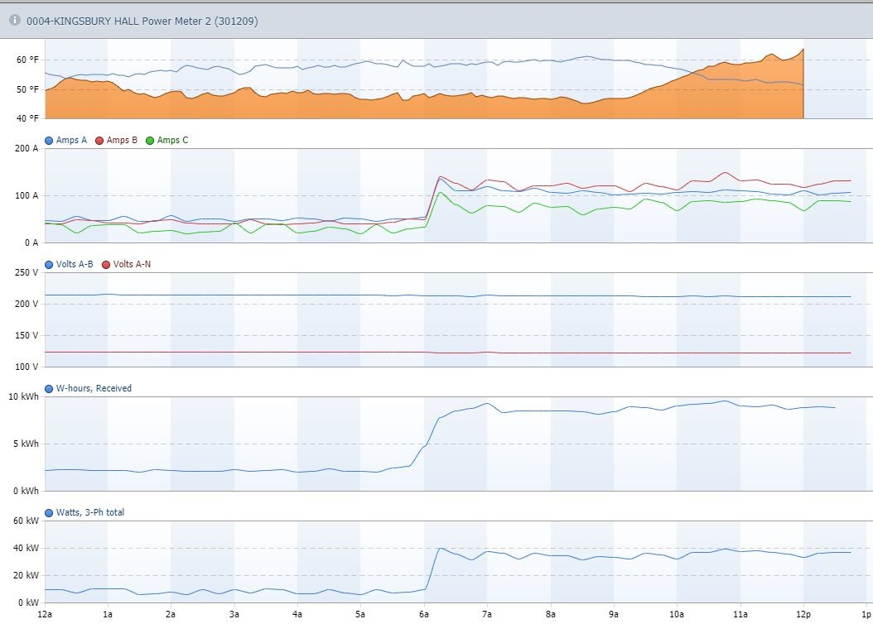

Figure 1. Example SkySpark visualization (Kingsbury Hall Power Meter 2)

Benchmarking building performance is possible with the SkySpark data, and the data may be used to directly measure the impacts of future SCIF projects. As facilities managers rely on this data to make decisions about campus utility systems, any improvements to the way the data can be visualized could help facilities personnel improve campus building efficiency.

Put simply, a better visualization of our campus energy usage, could help support decisions to make campus more sustainable.

**Project Objectives**

As students who pay fees, we would like to see that our money is going to good use and want to do our part to help make campus more sustainable. Our primary objective is to create a visualization of how energy efficient campus buildings are, discover which ones are the most and least efficient, and investigate any trends of energy usage over time. Our interest is to make it easy to see building performance, not review building data for a detailed maintenance purposes, so our display may lose some of the functionality of the SkySpark system, and is not intended to replace it by any means.

If possible, our secondary objective is to make the dashboard a live connection to real-time campus data for practical use by facilities personnel, students, researchers, and the public. To do this will require some additional permission from campus facilities personnel, and a meeting is scheduled with them for October 30th at 1 pm.

Visualization of campus building data in the SkySpark system has some limitations that our project would like to improve, namely:

1. Student accessibility

Our Github Repository will be made public and any student can use it to visualize at least a static dataset of the campus data. If this project goes well, and all stakeholders agree, this project could be incorporated into the SCIF map located at <http://greenmap.utah.edu/>​[,](http://greenmap.utah.edu/) or made otherwise available to the student body to visualize real-time data through a live connection.

1. Visualizations quality

As shown in Figure 1, SkySpark visualizations are limited to line charts for specific meters. We would like to improve the visualization of campus data through various ideas discussed in the ​**Visualization Design**​ section of this proposal.

1. Navigation

In the SkySpark system buildings are selected through a menu, which is shown below as Figure 2. Navigating this menu, and even reaching this menu, requires some knowledge of campus and the SkySpark client. It is fairly difficult to compare similar meters from different buildings or to compare multiple buildings using the SkySpark client. It is also difficult to know which buildings have and which buildings do not have data.

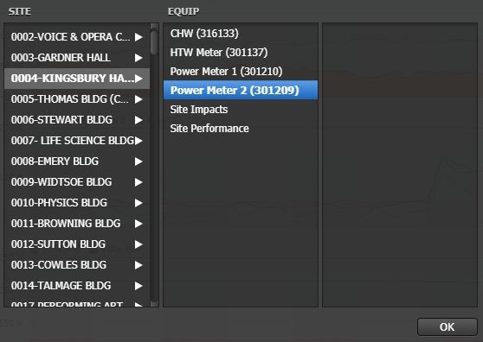

Figure 2. Screenshot of SkySpark navigation menu

Therefore, we would like to make it easier to navigate and select data, and make the interface intuitive for students and the public to use.

1. Context for non-technical users

The SkySpark system uses many abbreviations and metrics which are difficult for non-technical people to understand. Since our users will be students, researchers and the public, we will incorporate metrics which can be more easily understood and provide explanations of units wherever relevant.

**Data**

This project will use data from the Campus SkySpark system, Figure 3. SkySpark provides a rest web API for interfacing with the folio database through the AXON framework. This rest web

API provides JSON responses to dynamic queries of the data. We will use this API in two ways.

First, we will download a large static dataset, roughly a year of data from various buildings on campus.

Second, if we have enough time, we will set up a way to dynamically query the API via a live connection. As the data belongs to the U of U, access to it can be granted by facilities personnel upon request, however we cannot provide the access credentials in this proposal report.

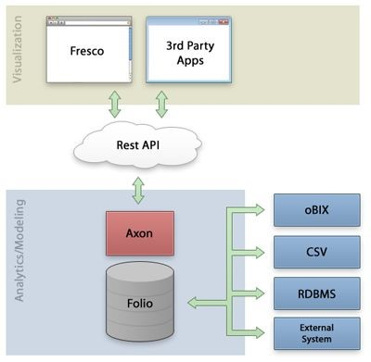

Figure 3. SkySpark system architecture [4]

A partial example of the JSON response table from the API is provided here:

"cols": [

{

"name": "ts",

"tz": "Denver",

"chartFormat": "D-MMM",

"dis": "Timestamp"

},

"rows": [

{

"ts": "t:2017-07-03T00:00:00-06:00 Denver",

"v0": "n:214.66666666666666 kBTU"

},

**Data Processing**

## Data Cleanup

From the example response shown above, it is clear that some characters will need to be removed, such as the time zone and the “t:” and “n:”. There also may be a number of queries which yield no response, since not every data point listed in the system has actual data. Handling null responses is therefore an important consideration if the visualization is to connect to live data. There may also be some calculations that will need to be performed on the data, such as averages or totals for a given time period.

## Derived Quantities from the Data

The campus data has many semantic forms, including:

* Amps,
* Volts,
* W-hours
* Watts,
* Temperature,
* Energy
* Energy Rate
* Building locations
* Building square footage

One key metric we would like to derive from the dataset is the Energy Use Intensity (EUI) of the buildings. This is taken as the energy in kBtu divided by the square footage of the building. This is a standard metric and is useful for comparing buildings of similar types against one another for their efficiency [5]. EUI is really the golden standard used to say how energy efficient a building is.

## How Data Processing will Occur

On the static dataset, data processing will need to be implemented within our code. Once a live connection is made, data processing can be partially performed via the rest API, but our code will need to handle the outputs and post-process and/or clean them dynamically.

## Visualization Design

Three alternative prototype design ideas (map, stacked area chart, and sortable bar chart) were conceived during a brainstorming session. Each of these design ideas is described in detail within this section and the is shown below as Figure 4. In addition to the three main design ideas, a tooltip feature will also be used, either on mouse click or on mouse hover, to bring up an infobox about the selected building.

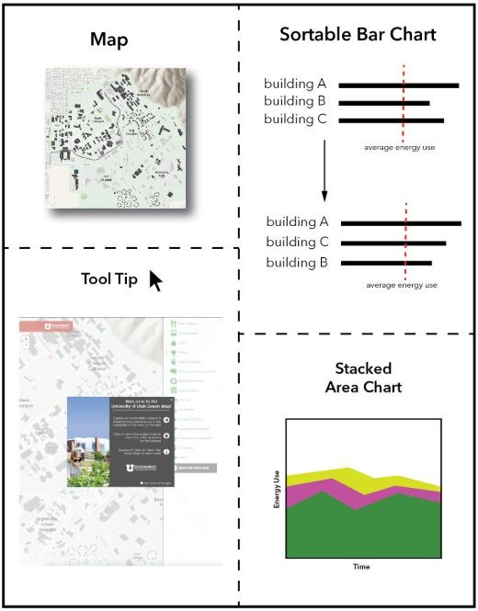

Figure 4. Final visualization design prototype

The team decided on these main features by using the Five Design Sheet method, which is attached with this proposal as a seperate PDF. A copy of the final design prototype is shown below as Figure 5.

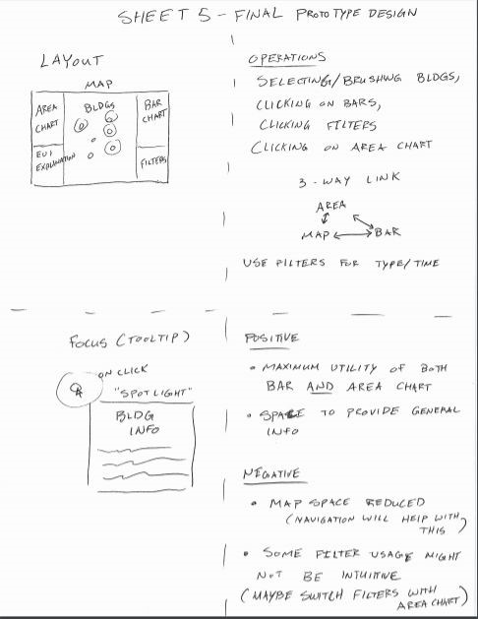

Figure 5. Copy of Sheet 5 (Final design prototype)

## Map

We would like to add an interactive map of campus, similar to one used by UC Davis, and compare building performance using an adequate metric. The UC Davis campus energy dashboard can be seen at ​[https://ceed.ucdavis.edu](https://ceed.ucdavis.edu/)​and a screenshot of it is shown below as Figure 6.

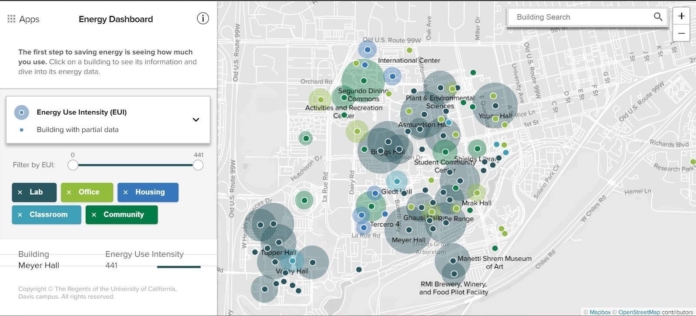

Figure 6. Screenshot of UC Davis Campus Energy Dashboard

The map we would like to incorporated will show the location and the EUI of each building on campus. The larger the EUI, the larger the circle around the dot of the building location. We also think it prudent to categorize the buildings by type using a color legend. The map will focus on high profile buildings, and we recognize that not all buildings on campus will be able to be represented, in which event we will create a blank marker to show that the data is not yet available.

## Stacked Area Chart

The stacked area chart design idea is that once a user selects a building, an area chart of the average EUI for that building over a selected time frame is generated. Then, if the user selects another building, a new area chart is stacked on top of the already existing area chart dynamically. In this manner, the user can select up to all of the buildings available and see how their EUI has performed over time. A conceptual example of a stacked area chart is shown below in Figure 7.

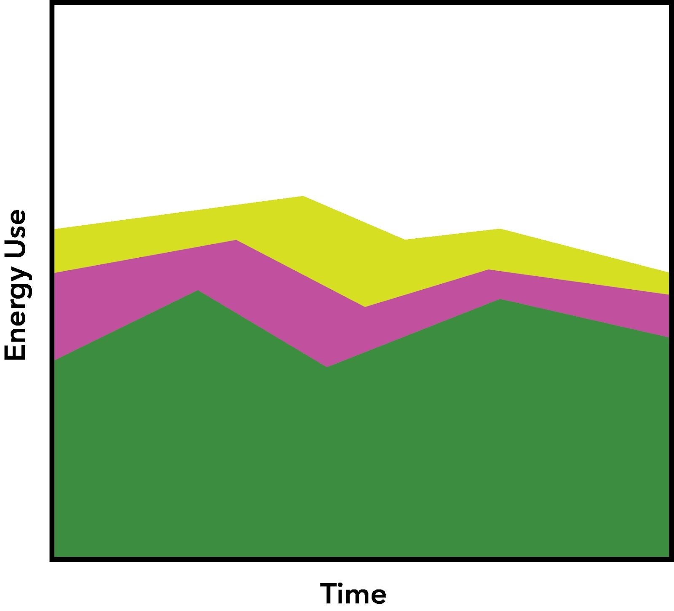

Figure 7. Conceptual example of a stacked area chart

This chart will be useful because it will show energy use trends over time for a single building as well as groups of buildings. It would also be nice if the addition of new areas to the stacked area chart would have some level of animation, so that the dynamics of how the change in selections could also be captured for the user.

## Sortable Bar Chart

Since ranking buildings against each other is a primary goal of the visualization, we decided on a sortable bar chart. A conceptual example of the sortable bar chart is shown below as Figure 8.

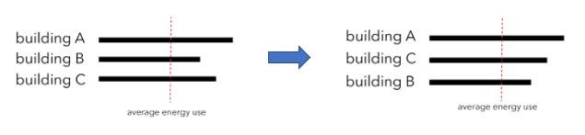

Figure 8. Sortable bar chart

The advantage of the sortable bar chart is that it will allow for the user to find a building based on its name, ordered alphabetically. It will also allow the user to see the ranking of top energy usage across buildings.

## Must Have Features

By priority, the map and the sortable bar chart are absolute must have features. The tooltip and stacked area charts are also must have features with a slightly lower priority, since they require more information wrangling and would be greatly improved by outside information. Everything shown in Figure 4 should is a must have feature.

## Optional Features

There are a number of optional features which we would like to include, if we have the time/permission.

These are:

1. Connection to live, real-time data (this is optional primarily because we do not know what campus facilities will think of the idea at the time of writing this proposal)
2. Linking the three main displays (sorted bar chart, stacked area chart, and map)
3. Animation of the stacked area chart
4. Other units of measurement, for example how many man hours of bicycling it would take to produce the energy used in the buildings
5. Categorical sorting, for example comparing all the engineering buildings to each other
6. Inclusion of calendar data, for example summer months versus school season or weekdays versus weekends

## Project Schedule

The deliverables and due dates of each aspect of the project are outlined below:

Announcement of Project Team & Topic 10/19/2018

Let the class know our team and topic

Project Proposal Write-up 10/28/2018

Create the project description and outline

Prepare Dataset 10/30/2018

Gather JSON responses and post on Github

Explore methods for trimming and cleaning the data Check dataset for any missing data and organize

Team Discussion 10/30/2018

An in-class review of the project. Feedback from the TAs and other groups.

Work Assign & Design 10/31/2018

Review all tasks in detail and assign any new tasks as a result of the Team Discussion.

Make the map 11/01/2018

Create the map and build necessary links between building names, locations, and energy data

|  |  |
| --- | --- |
| Make bar chart  Create sortable table of the building energy data | 11/05/2018 |
| Project Milestone  Have a working visualization of the bar chart and map (linked)  Have a clear data mapping for the tooltip and Stacked Area Chart | 11/09/2018 |
| Make Stacked Area Chart | 11/16/2018 |
| Make Tooltip | 11/23/2018 |
| Link all displays and add Optional Features | 11/26/2018 |

If possible create a dynamic link to real-time data

If possible add Calendar, categorical sorting, other metrics, animations

Make Screen Cast 11/29/2018

Create a video documenting the project, also add any extra documentation and finishing touches.

Submit Final Project 11/30/2018

## References

[1] ​<https://sustainability.utah.edu/wp-content/uploads/sites/19/2017/02/SCIF-Bylaws-2017.pdf> [2] ​<https://sustainability.utah.edu/scif/>

1. ​<https://sustainability.utah.edu/progress/focus-areas/energy-buildings/>
2. ​<https://www.seiberlich-analytics.com/doc/docSkySpark/Architecture.html>
3. ​[https://www.energystar.gov/buildings/facility-owners-and-managers/existing-buildings/use-portfoli](https://www.energystar.gov/buildings/facility-owners-and-managers/existing-buildings/use-portfolio-manager/understand-metrics/what-energy)

​o-manager/understand-metrics/what-energy

See Attached Five Design Sheet Method Pages PDF

# Peer Feedback

Comments from Reviewers (10/30/2018):

* Consider using metrics that students will understand (like maybe a hamburger metric) to represent the energy usage and incorporate a visualization using the selected metrics.
* Consider having a calendar for the time series which makes the visualization more interactive (optional feature) as part of must do.
* Categorize the various buildings based on their use (labs, dorms, classrooms, etc).
* Tooltips with dynamic display of the building energy usage.
* ​Create a table for calculating cost estimation by factors like sqft, watts, power, watts to hot water and type.
* The reviewers expect some sort of meaningful visual representation for possible future energy usage, and not just tabular data format.

Peer Reviewing Team Members: ● Brett Reader

* Srivasthsan Ramesh ● Abhinandan Baireddy

Results from peer feedback:

* Unit conversion considerations
* Priority given to area chart over bar chart for milestone deadline
* Calendar is now a must have feature

# Milestone Report

## Milestone Achievements

As of the first milestone deadline, the display has a working map shown below as Figure A, and a working area chart, shown below as Figure B. The area chart was given priority over the bar chart idea found in the initial design plan due to the peer feedback. It was also determined to be more difficult to implement and should likewise be prioritized.

A few iterations were used to explore the data and the data can be categorized as comprised of two sets 1) Relational, and 2) Temporal.

Relational data was initially investigated through the “campus locations.csv” file (a handmade file from point markers on google maps). Eventually the team discovered a complete relational dataset for the campus. The name of this dataset is “CSV_FULL_SITE_LIST.csv”. The map (Figure A) shows that the team has created a foundation for manipulating the relational dataset.

Figure A. Map with Building Locations (red dots).

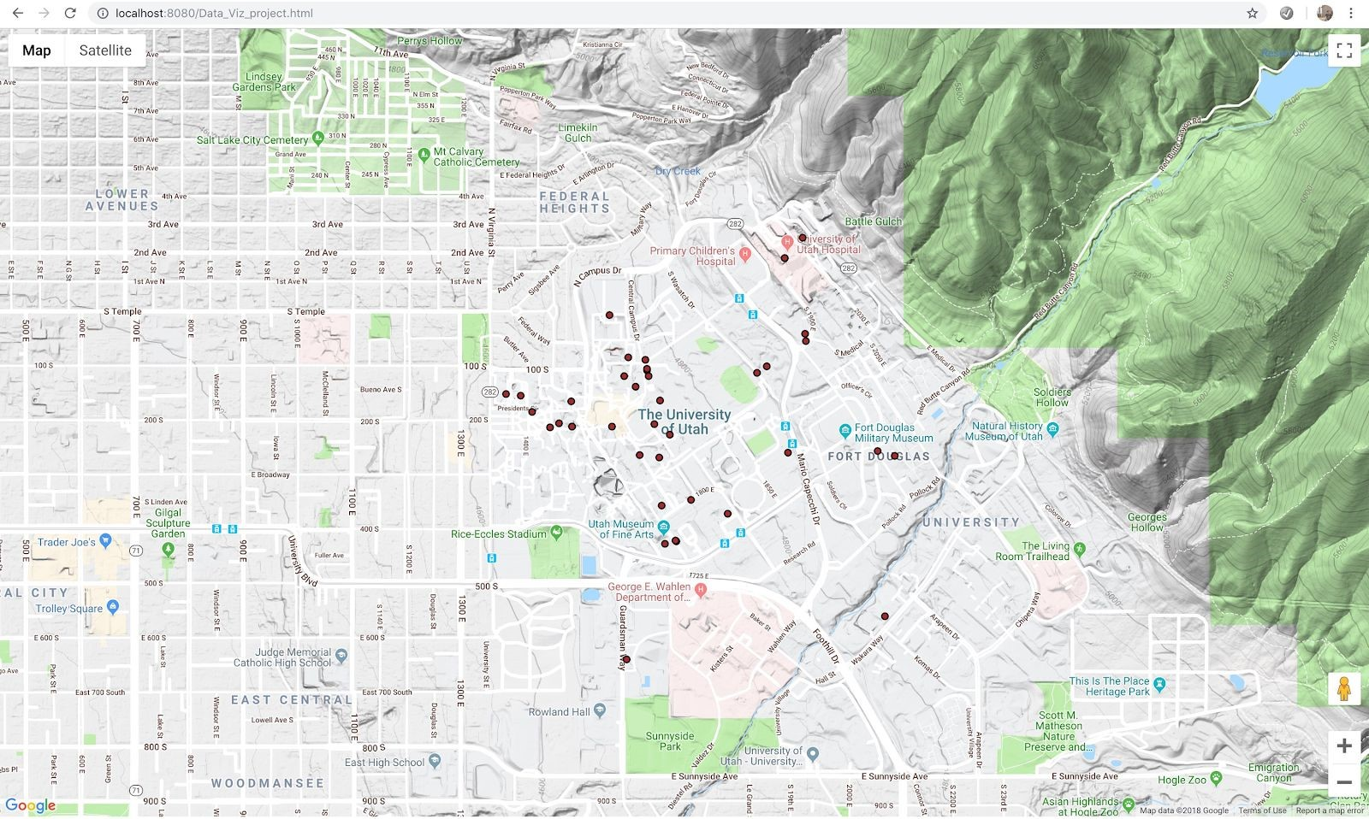

As far as the temporal data is concerned, while the project does not yet have every JSON file that will be used for the full implementation at the time of the milestone, there are enough files to adequately represent the variance between responses that would be read from the live API, and the files themselves don’t constitute significantly different data architecture as to suggest that the sample of JSON files is not representative of all data that will need to be handled. The area chart (Figure B) shows that the team has established a foundation for manipulating the temporal dataset.

Figure B.​​Area Chart (Browning Building)

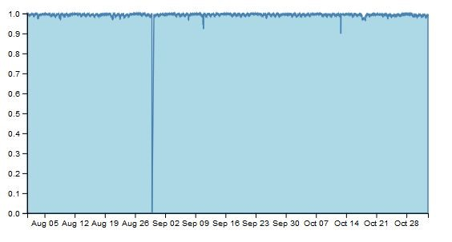

In order to link the temporal data with the relational data, it was discovered that the JSON “siteref” object, matches exactly with the “ID” field of the CSV file used for the buildings. This link is quite convenient and the team is confident that the remainder of the project will come together nicely.

## Adjusted Timeline

An adapted timeline with changes for the remainder of the project is as follows:

Make Bar chart 11/16/2018

Make Tooltip 11/23/2018

Add Calendar, link all displays and add Optional Features 11/26/2018

~~If possible create a dynamic link to real-time data (~~​This was not approved by campus)

If possible ~~​add Calendar~~​, categorical sorting, other metrics, animations (Calendar was made required)

Make Screen Cast 11/29/2018

Create a video documenting the project, also add any extra documentation and finishing touches.

Submit Final Project 11/30/2018

# Final Adjustments

## API Queries and Data Wrangling

In our project we encountered a lot of difficulty querying the API for the correct energy tags, treating the queries and compiling them into a static data set. The source.py file on the repository was used to handle and combine multiple queries from the same building into a final value. The path for the source.py file is located here:

<https://github.com/Abhilash0112/uofucampusenergyviz/blob/master/Data_Viz_Project/data/cleaned_json/source.py>

The resulting files used in the static dataset are located at:

<https://github.com/Abhilash0112/uofucampusenergyviz/tree/master/Data_Viz_Project/data/Final_Static_DataSet>

Even with these files the process was not completely automated. We suggest more exploration of the Skyspark Folio database be performed if this is to be attempted with a real-time live connection.

In total, data from 83 buildings was aggregated out of responses from the rest web API.

Implementation

Map

The map shows the exact geographical locations of the building in the campus with the circles as markers, the size of the circles is based on the total Area square feet of the respective building. The color displayed on the circles is based on the Category of the building and with this we can clearly differentiate between the types and categories of the buildings and it is pretty obvious that more the Area sqft more the energy consumption of the respective building.

A close up of a map


We have also added another useful functionality by creating a tooltip on mouseover which shows and displays the important and relevant information of the respective building such as type of the building, Area of the building and name of the building which makes it simpler for viewers to the kind of building they are looking at and the energy consumption of the building.

**Table**

The table explains about the categories of the buildings available in the vicinity with the corresponding square feet size of the building in the area column. Primary usage of the building column denotes the functionality of the building for which the particular building is being used. Type denotes the specific type and subtype of the building.

Upon clicking the dropdown menu, it takes the input of the user and filters the table data according to the category of the building.

**A screenshot of a cell phone

**

On click of the particular record of the table, it displays a bar chart which indicates the power consumption of the particular category of the building.